Question 1

import java.io.BufferedReader;

import java.io.IOException;

import java.io.InputStreamReader;

import java.text.DecimalFormat;

import java.util.Scanner;

class CustomerPurchase

{

int customernumber;

String firstname;

String surname;

String product;

double productprice;

int quantity;

public CustomerPurchase() {

this.customernumber=customernumber;

this.firstname=firstname;

this.surname=surname;

this.product=product;

this.productprice=productprice;

this.quantity=quantity;

}

public int getCustomernumber() {

return customernumber;

}

public void setCustomernumber(int customernumber) {

this.customernumber = customernumber;

}

public String getFirstname() {

return firstname;

}

public void setFirstname(String firstname) {

this.firstname = firstname;

}

public String getSurname() {

return surname;

}

public void setSurname(String surname) {

this.surname = surname;

}

public String getProduct() {

return product;

}

public void setProduct(String product) {

this.product = product;

}

public double getProductprice() {

return productprice;

}

public void setProductprice(double productprice) {

this.productprice = productprice;

}

public int getQuantity() {

return quantity;

}

public void setQuantity(int quantity) {

this.quantity = quantity;

}

}

class Printing extends CustomerPurchase

{

void PrintDetails()

{

System.out.println("CUSTOMER INVOICE");

System.out.println("****************************");

System.out.println("CUSTOMER NUMBER: "+getCustomernumber());

System.out.println("CUSTOMER FIRST NAME: "+getFirstname());

System.out.println("CUSTOMER SURNAME: "+getSurname());

System.out.println("PRODUCT PRICE: R "+getProductprice());

System.out.println("PRODUCT QUANTITY: "+getQuantity());

System.out.println("****************************");

}

void Customerpurchasereport()

{

DecimalFormat d1=new DecimalFormat("#.00");

double total=(getProductprice()+getProductprice()*0.15)-(getProductprice()*0.1+getProductprice()*0.085);

System.out.println("CUSTOMER PURCHASE REPORT");

System.out.println("****************************");

System.out.println("PRODUCT PRICE: R "+d1.format(getProductprice()));

System.out.println("TAX: R "+d1.format(getProductprice()*0.15));

System.out.println("COMMISION: R "+d1.format(getProductprice()*0.085));

System.out.println("DISCOUNT: R "+d1.format(getProductprice()*0.1));

System.out.println("TOTAL: R "+d1.format(total));

System.out.println("****************************");

System.out.println("Application complete");

}

}

public class Main {

public static void main(String[] args) throws NumberFormatException, IOException {

// TODO Auto-generated method stub

int option;

BufferedReader inp = new BufferedReader (new InputStreamReader(System.in));

System.out.print("Enter the customer number >> ");

int n=Integer.parseInt(inp.readLine());

System.out.print("Enter the customer first name >> ");

String firstname=inp.readLine();

System.out.print("Enter the customer Surname >> ");

String surname=inp.readLine();

System.out.print("Enter the product >> ");

String product=inp.readLine();

System.out.print("Enter the product price >> ");

int prdtprc=Integer.parseInt(inp.readLine());

System.out.print("Enter the quantity required >> ");

int quantity=Integer.parseInt(inp.readLine());

Printing p1=new Printing();

p1.setCustomernumber(n);

p1.setFirstname(firstname);

p1.setSurname(surname);

p1.setProduct(product);

p1.setProductprice(prdtprc);

p1.setQuantity(quantity);

p1.PrintDetails();

System.out.println("Would you like to view the product purchase report? Enter(1)");

System.out.println("to view the purchase report or any other key to exit");

option=Integer.parseInt(inp.readLine());

if(option==1)

{

p1.Customerpurchasereport();

}

else

{

System.out.println("Application complete");

System.exit(0);

}

}

}

Question 3

/**********************************CourseDetails.java********************************/

import java.util.Random;

/**  
* The Class Course_Details.  
*/  
public class Course_Details {

   /** The course code. */  
   private String courseCode;

   /** The course name. */  
   private String courseName;

   /** The student numbers. */  
   private int studentNumbers;

   /** The lecturer name. */  
   private String lecturerName;

   /**  
   * Instantiates a new course details.  
   */  
   public Course_Details() {

       this.courseCode = "";  
       this.courseName = "";  
       this.studentNumbers = 0;  
       this.lecturerName = "";  
   }

   /**  
   * Instantiates a new course details.  
   *  
   * @param courseCode the course code  
   */  
   public Course_Details(String courseCode) {  
       this.courseCode = courseCode;  
       this.courseName = "";  
       this.studentNumbers = 0;  
       this.lecturerName = "";  
   }

   /**  
   * Gets the course name.  
   *  
   * @return the course name  
   */  
   public String getCourseName() {  
       return courseName;  
   }

   /**  
   * Sets the course name.  
   *  
   * @param courseName the new course name  
   */  
   public void setCourseName(String courseName) {  
       this.courseName = courseName;  
   }

   /**  
   * Gets the student numbers.  
   *  
   * @return the student numbers  
   */  
   public int getStudentNumbers() {  
       return studentNumbers;  
   }

   /**  
   * Sets the student numbers.  
   *  
   * @param studentNumbers the new student numbers  
   */  
   public void setStudentNumbers(int studentNumbers) {  
       this.studentNumbers = studentNumbers;  
   }

   /**  
   * Gets the lecturer name.  
   *  
   * @return the lecturer name  
   */  
   public String getLecturerName() {  
       return lecturerName;  
   }

   /**  
   * Sets the lecturer name.  
   *  
   * @param lecturerName the new lecturer name  
   */  
   public void setLecturerName(String lecturerName) {  
       this.lecturerName = lecturerName;  
   }

   /**  
   * Gets the course code.  
   *  
   * @return the course code  
   */  
   public String getCourseCode() {  
       return courseCode;  
   }

   /**  
   * Assign vanue.  
   *  
   * @return the int  
   */  
   public static int assignVanue() {

       return new Random().nextInt(3) + 1;

   }

   @Override  
   public String toString() {  
       return "Course Details \nCourse Code: " + courseCode + "\nCourse Name: " + courseName + "\nStudent Numbers: "  
               + studentNumbers + "\nLecturer Name: " + lecturerName;  
   }

}

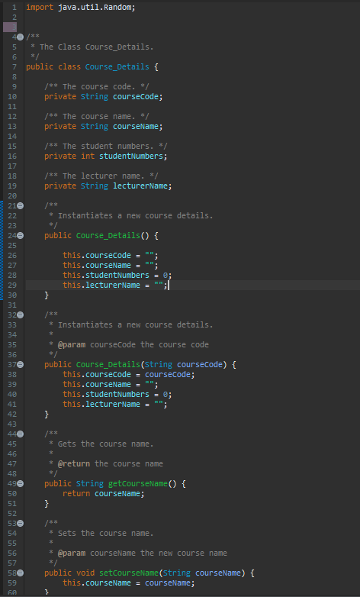

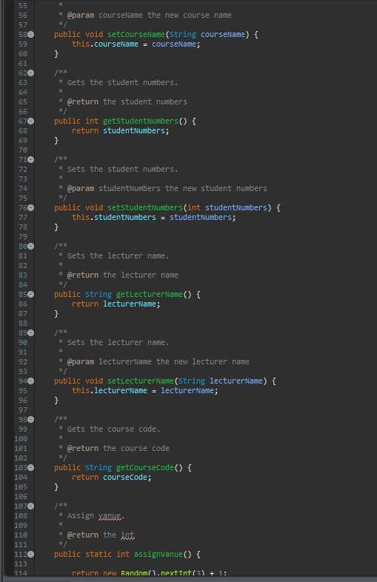

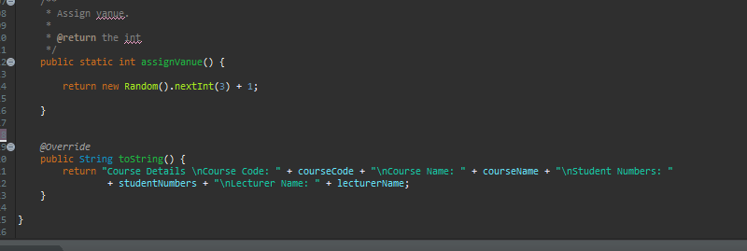

/*****************************MainCourse_Details.java***********************./

import javax.swing.JOptionPane;

public class MainCourse_Details {

   public static void main(String[] args) {

       // create a course details named disd  
       Course_Details disd = new Course_Details("DISD");  
       // set course name  
       disd.setCourseName("Diploma in Software Development");  
       // set student number  
       disd.setStudentNumbers(35);  
       // set lecturer name  
       disd.setLecturerName("Mr Jones");

       // create a course details named diwd  
       Course_Details diwd = new Course_Details("DIWD");  
       diwd.setCourseName("Diploma in Web Development");  
       diwd.setStudentNumbers(28);  
       diwd.setLecturerName("Mrs Smith");

       // create a course details named didm  
       Course_Details didm = new Course_Details("DIDM");  
       // set course name  
       didm.setCourseName("Diploma in Data Matrics");  
       // set student number  
       didm.setStudentNumbers(39);  
       // set lecturer name  
       didm.setLecturerName("Mr Ntsinga");

       //do while loop to see the all courses till user not entered another number  
       int input = 0;  
       do {  
           input = Integer.parseInt(JOptionPane.showInputDialog(  
                   "Select from the following to view the course details:\n" + "1) DISD\n" + "2) DIWD\n" + "3) DIDM"));

           if (input == 1) {

               JOptionPane.showMessageDialog(null, disd.toString());  
           } else if (input == 2) {

               JOptionPane.showMessageDialog(null, diwd.toString());  
           } else if (input == 3) {

               JOptionPane.showMessageDialog(null, didm.toString());  
           }  
       } while (input <= 3 && input >= 1);

       //Assign the class  
       int classNo = Course_Details.assignVanue();

       if (classNo == 1) {

           JOptionPane.showMessageDialog(null, "Following class is Scheduled: \n" + disd.toString());  
       } else if (classNo == 2) {

           JOptionPane.showMessageDialog(null, "Following class is Scheduled: \n" + diwd.toString());  
       } else {

           JOptionPane.showMessageDialog(null, "Following class is Scheduled: \n" + didm.toString());  
       }

   }  
}  
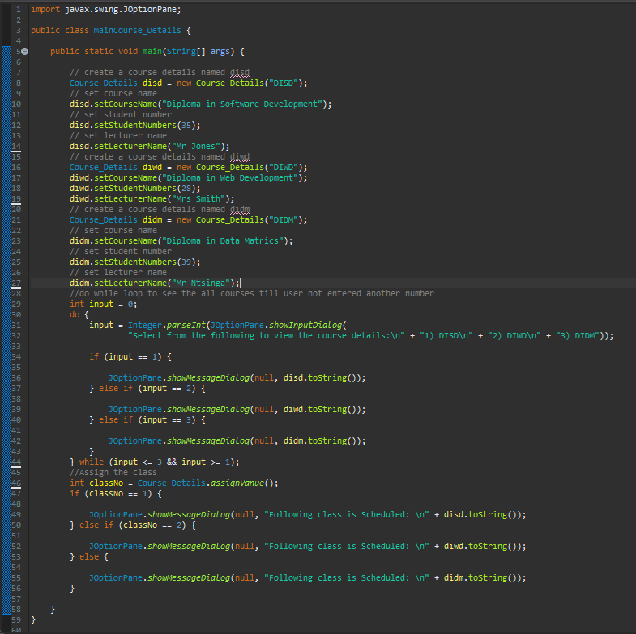

/*************************output*******************/

